Now we are going to talk about in React native how to use component inside flatlist

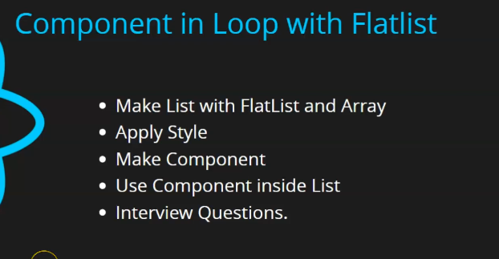

Even though Teacher has made lesson already on it and three or four lessons are on the list and also one on grid so what will be different in this lesson

In the last Flatlist component we had not used any custom component neither any props inside it what we will do is make a custom component and use it inside Flatlist and our component will run inside loop and inside those component we will get props and we will print it also so you can say we will learn many dynamic things

0:35

**Note:-**

In React native even if the command npm run android does not get fully(run like a cammand execution no like a process is going on like a server) executed even then new update will be rendered on screen

And these are practical think that you need definitely when we do react native So lets start with list first we will make a flat list and array and then we applty some styles on it and whatever text we will keep in Text component. We will place it in a component and we will use it inside a flatlist and a loop will run and in this flatlist we will pass props through it and in last some interview question will be asked

We will use s list similar to previous list as shown below

 const users = [

  {

    id:1,

    name:'Anil',

    email:'abc@test.com'

  },

  {

    id:2,

    name:'Sam',

    email:'abc@test.com'

  },

  {

    id:3,

    name:'Peter',

    email:'abc@test.com'

  },

 ]

Now we will import our flatlist

And add the data to it by data prop and always remember it should be an array and then through render Items we will tell how our list item will look It just take call back function

We so this

   <>

    <Text style={{fontSize:31}}>

      Component in Loop with FlatList

    </Text>

    <FlatList data={ users } renderItem={({item})=><Text>{item.name}</Text>}/>

    </>

Now in output it will look

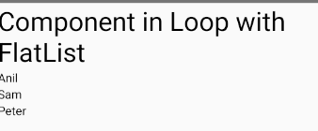

Noe you can see all user names but it is very small list we will write properly because here only names we just want load email if you want to take both of thing we need to create wrapper first times to take both of things so we take view as wrapper and then inside it we write two text component one telling the name and another telling the email

When we say element or tag we call it as component because in react native everything is component

<FlatList data={ users } renderItem={({item})=>

      <View>

        <Text>{item.name}</Text>

        <Text>{item.email}</Text>

      </View>}/>

So output will be



But they all look as an individual element we cannot distinguish the pair but don’ t worry we will just add styles we will apply internal css

So for the styles of item we set fontSize as 24 and color as orange

And we set flex as 1 we do it so so that each element cover half of the area (,eam in cross axis of the direction we are in whether it is column for vertical or row for horizontal) even teacher will teach us about flex that how it is working don’t worry we will understand it later

Now we take margin as 2 (default pixel maybe)

const styles = StyleSheet.create({

  item: {

    fontSize: 24,

    color:'orangw',

    margin:2,

    flex:1,

    },

  box:{

    flexDirection:’row’

  }

});

Above is the current style

<FlatList data={ users } renderItem={({item})=>

      <View>

        <Text style={styles.item}>{item.name}</Text>

        <Text style={styles.item}>{item.email}</Text>

      </View>}/>

Now for box style we set flexdirection as row which we will add to View style

Now the output will be like below



So now each row represent a different item in the list

We now add the borderWidth as 2 , and set borderColor as orange

And marginBottom as 10 to box

Now our output will be like below

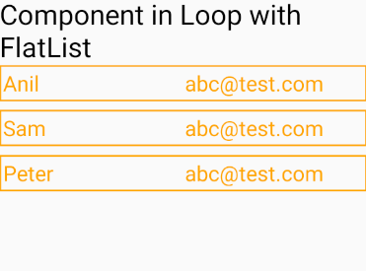

Now our these three item are being rendered properly

If we want to give textalign center to the items then you can do so

If you want to check how much area it covers just for once take a background color we take green

Now it will look like below

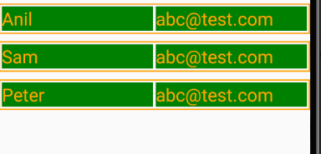

Now you can See how much are covered by Text It was just for clearing concept you can use but if you don’t want to use no problem So we do text Align that is center that is textAlign : center

Now output will be like below

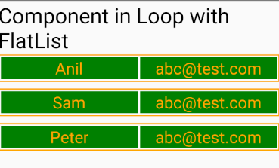

Now we want that this data should go through different component (I don’t know)

Now we are going to render component inside a Flatlist

**Note:-**

I think the height of the total UI Is not equal to screen but the content taking the size vertically (I don’t know)

Now we make a Component UserData and we will place all the code we used in render Item

const UserData = ()=>{

  return(

    <View style={styles.box}>

    <Text style={styles.item}>{item.name}</Text>

    <Text style={styles.item}>{item.email}</Text>

  </View>

  )

}

    <FlatList data={ users } renderItem = {( { item } )=>

     <UserData/> }/>

Now the problem is that we could not pass name and email to the component

It will show error like

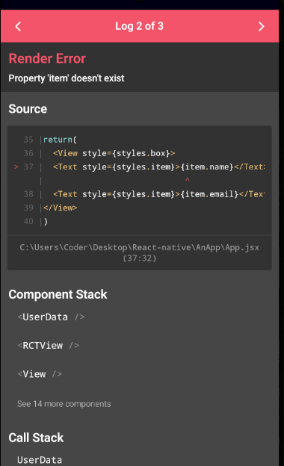

Item does not exist we will just simply pass a prop item and set its value to item we get from loop it

Will look like below

 <FlatList data={ users } renderItem={( { item } )=>

     <UserData item={ item }/> }/>

And now in UserData component we set the parameter as props for handling props

Now we take a local variable item and set it to props.item to access each item

Now if we save this time it will work

const UserData = (props)=>{

  const item = props.item

  return(

    <View style={styles.box}>

    <Text style={styles.item}>{item.name}</Text>

    <Text style={styles.item}>{item.email}</Text>

  </View>

  )

Now this component is being rendered three times

In interview the question could ask can you use custom component in the Flatlist

And second they could ask how you will pass props then you can tell so as you know about it

Second question could be asked that can we pass multiple props

Yes you could do pass as many props you want

Suppose we have passed props like data

And then we can acces it like props.data similar tpo like we did with item

Now we will keep our component in a separate file

It is not difficult it is very easy

Inside component folder we make a file as UserData.js

Now we need style inside our UserData component not outside component so we will move component and style to UserData.js

11:25

And also do import the component that is used in Userdata as it is not win new file

We need to import UserData in App.jsx

So we import Userdata by the following way below

import UserData from './components/UserData';

Now the output shown below

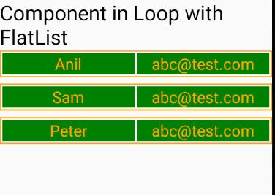

Now in next lesson we will see selection list later we will end this list topic and will focus on other things